Sleep Stations = Safe Overnight Sleep 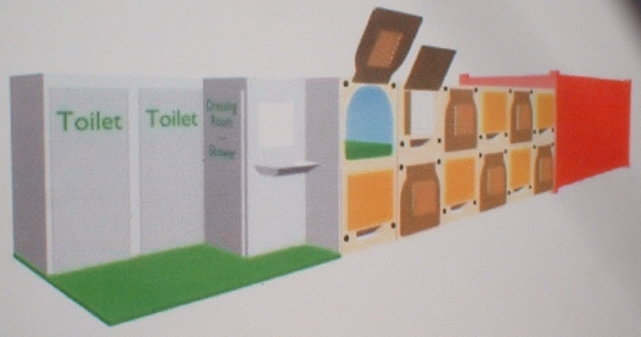 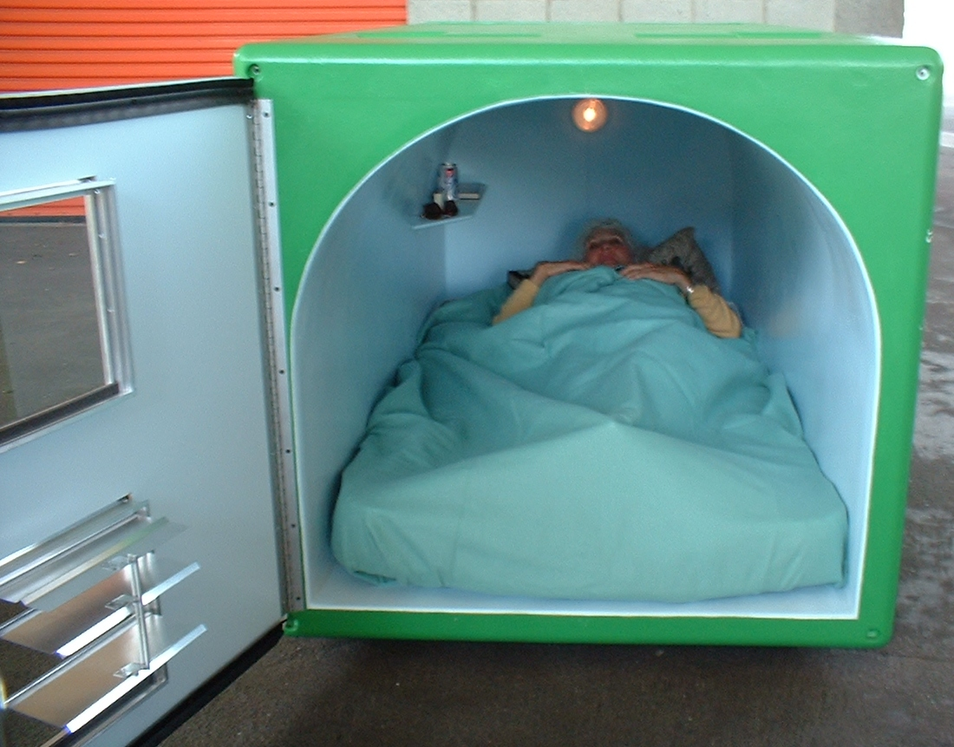
Sleep Station (US Patent No. 6981347) Sleepin (US Patent No. 6981347)

Comfortable Private Sleepin Modules, Private Lockbox, Shower, Sink, Water Fountain and Stand Alone Locking Steel Container for Day Storage
Specifications and specifics:
Sleepins;

- can be constructed out of many materials and processed utilizing vacuum or roto-molding for the outer ¼ inch thick shell,
- insulated by 3 inches of fire retardant acoustic material,
- exterior is 7’6” long, 3’9” wide and 3’ 6” high,
- inner is 7’ long, 3’ 3” wide and 3’ high,
- fits a twin bed mattress,
- light and shelf,
- ventilated front to back and louvered screened window,
- arched ceiling provides strength and visual comfort,
- has adjoining private lockbox exterior 3’6” high, 3’9” wide and 3’6” deep,
- can be placed single or double high and in any arrangement necessary to meet space requirements,

Sleep Stations include;
- accommodate 10 to 12 people,
- two toilets, a shower/dressing room module, electric water heater, sink, faucet and drinking fountain,
- 10’x20’ locked storage container with interior pallet racks for daytime storage,
- occupies 550sq.ft. to 650sq.ft. depending on arrangement,
- may use a safety light and camera,

Station sites and locations;
- usually occupied from 9pm to 7am nightly,
- site can serve dual use during the day,
- any flat surface indoors or out that is at least 550sq.ft.,
- modules can fit irregular spaces,
- locations such as unused commercial or industrial storage space or areas, bits and pieces of government owned utility areas near industrial or spaces around transit lines,
- other unused county or city property,
- private owners of suitable space could receive a county property tax credit for placing a Sleep Station on their land,
- sites could be deployed evenly across the county,
- besides a flat surface, water, grey water and electricity hookup is necessary,

P.2
Staffing;

- site manager’s job is to always insure the security and comfort of everyone,
- managers receive training and are qualified to maintain order and deal with disorderly situations,
- in the morning the manager locks people’s chosen possessions into the steel storage container and issues a claim ticket,
- site manager is responsible for the sites overall cleanness and maintenance,
- besides site manager other paying jobs may include, plumbing, electrical, assembly, maintenance, transportation and laundry work,
- protocols for different uses will develop, i.e. homeless shelter, emergency shelter, etc.,

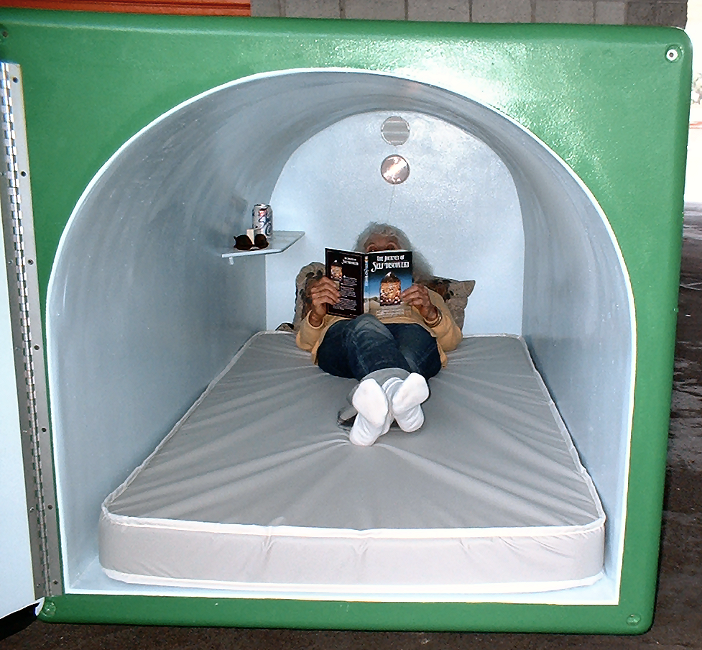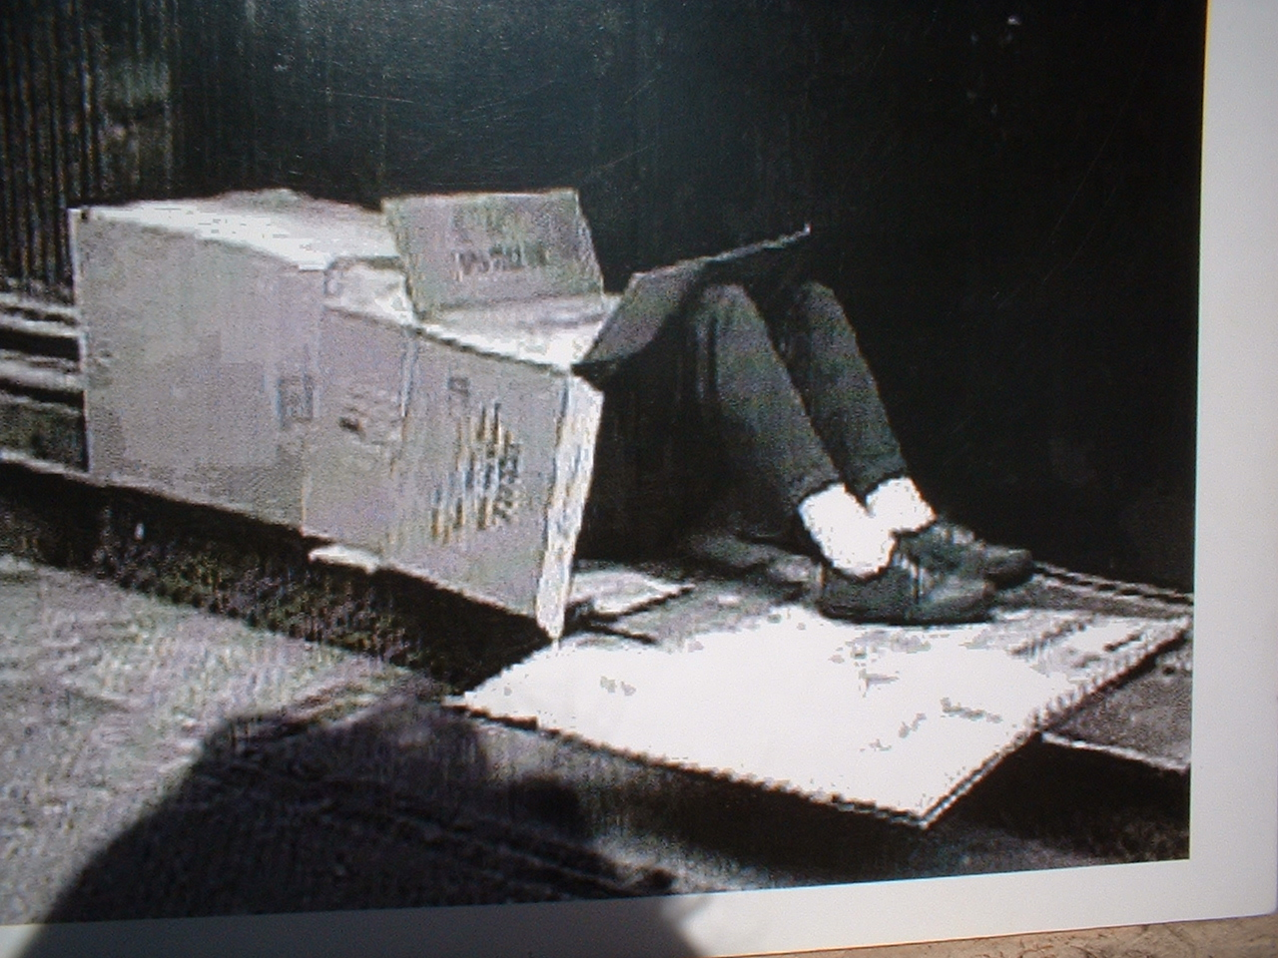

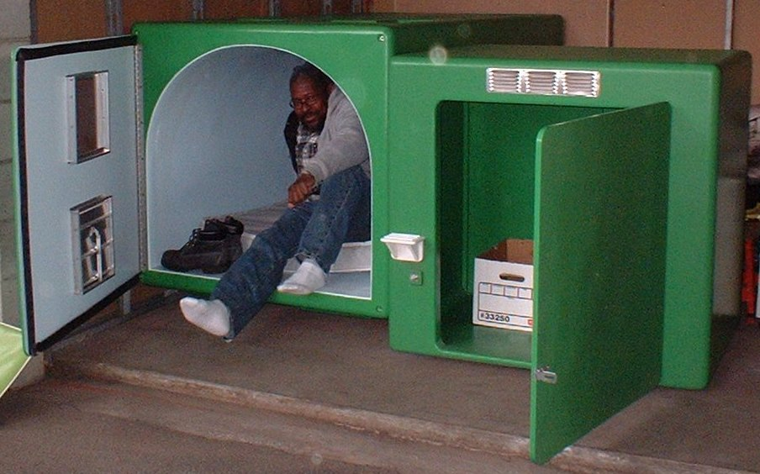
Sleepin with private lockbox U.S. Patent No. 6981347
Contact: Randy Walburger
rwshelters@verizon.net
www.hopemakingchange.org
Click SOS at home page
Because no one should have to sleep on the ground scared, alone and vulnerable
As holder of Modular Emergency Shelter System, U.S. Patent 6981347
I will take no royalties when used for homeless people

